Building Flat Rate Jobs in ROM: This topic covers using ROM to build flat-rate jobs that can be applied to repair orders.

New Estimate: Click on this button to start building the job.

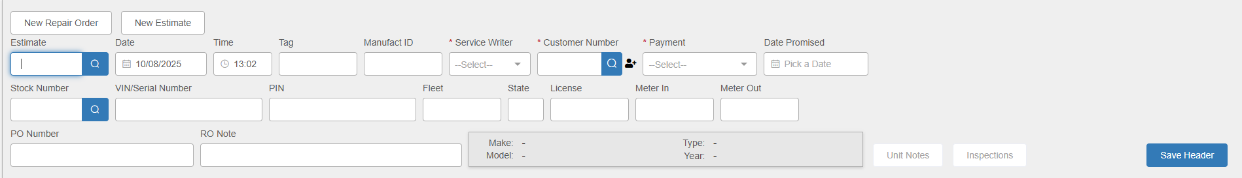

Header Fields:

Service Writer ID #: Enter the Service Writer ID # or use the dropdown menu to look it up.

Customer Number: Enter:

- Your designated Internal customer (typically 00004) if you are creating an Internal job
- Your designated Warranty customer (typically 00007) for a Warranty job
- Customer # 00000 if you are creating a Customer job

NOTE: If you see a pop-up box of open repair orders appear, click on the Start New RO button to bypass it.

Payment: The Method of Payment (MOP) defaults from the Customer Master based on what kind of job you’re building. This is only a suggested payment option.

RO Note: You may optionally fill in “Use this RO for building Flat Rate Jobs.”

Save Header: Click this button to create the estimate.

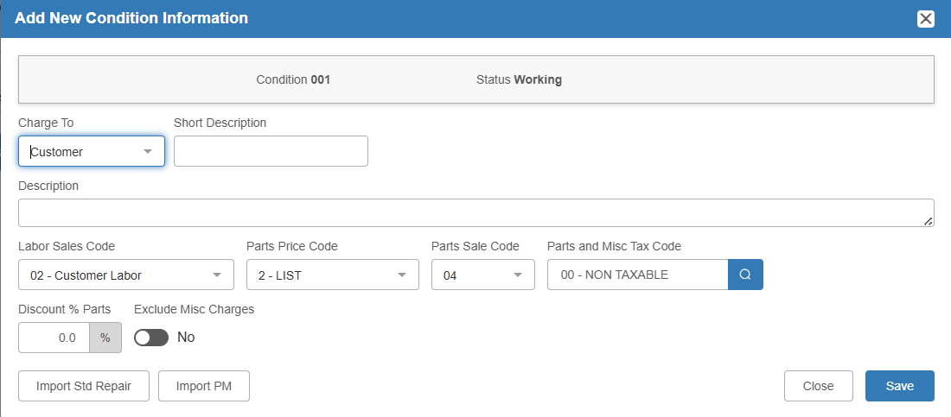

Add New Condition: This screen will automatically open once the estimate is created. Use it to built your Flat Rate Job.

Charge To: Leave this field defaulted based on your selected customer so that the job will be built according to that charge type’s accounting parameters (i.e. if you picked the Customer option, leave it as in the image above).

Short Description: Fill in a brief description of the Flat Rate Job.

Description: You may fill in more details of the job here if desired.

Codes: These codes will default from the Customer Master. Change/select only if needed. The codes are:

- Labor Sales Code
- Parts Price Code
- Parts Sales Code
- Parts and Misc Tax Code

Discount % Parts: Only fill this field in if it’s applicable to the job you’re building.

Save: Click this button to save the job as a condition and move on to adding the OP Code.

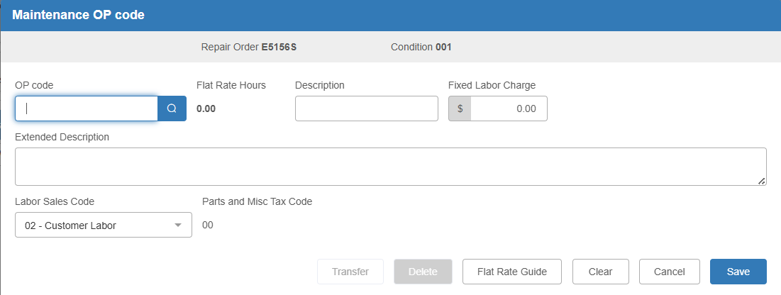

Add OP Code: Enter or look up the desired OP code, then fill in the remaining fields as you would on a normal condition. Click Save when finished to return to the main screen.

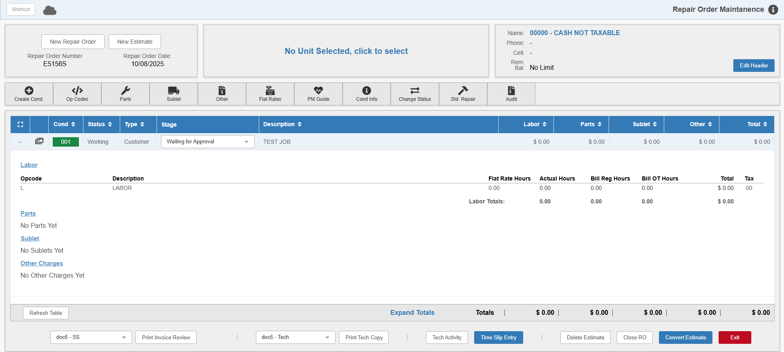

Add Parts: If you need to add parts to the job, expand the condition and click Parts to open the Service Parts POS screen.

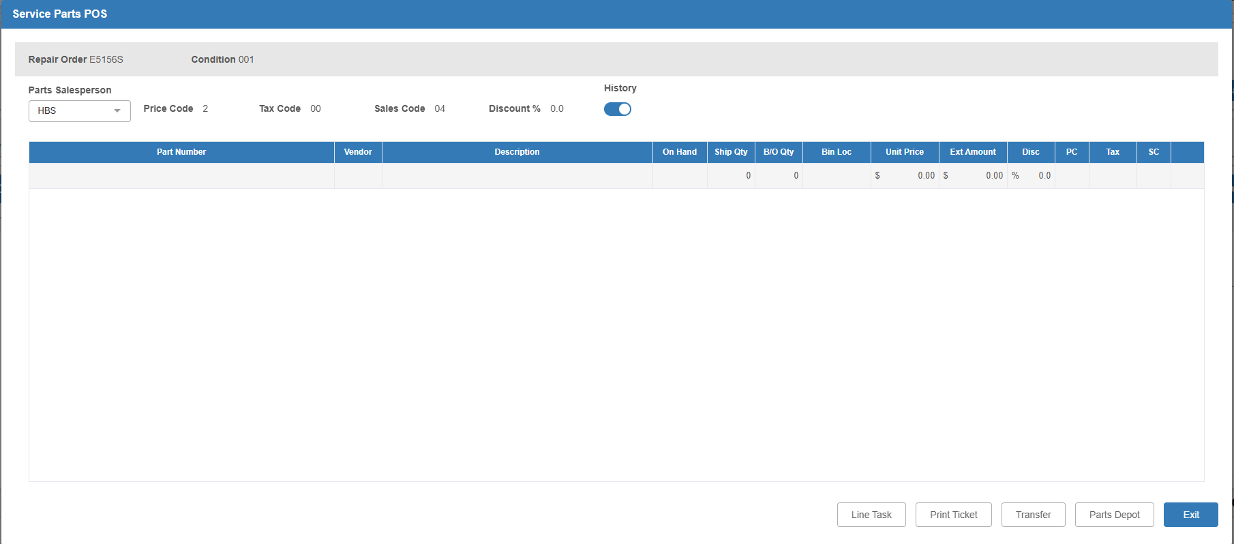

Select your Salesperson ID and add as many parts as needed. The parts will automatically be saved to the job as you finish each line. Click Exit when you’re done to return to the main screen. All the selected parts will be listed on the condition.

Finishing the Flat Rate Job: Add any other details for the job as needed. Once finished, making sure you still have the condition selected, click Condition Information (Cond Info) to open the following window:

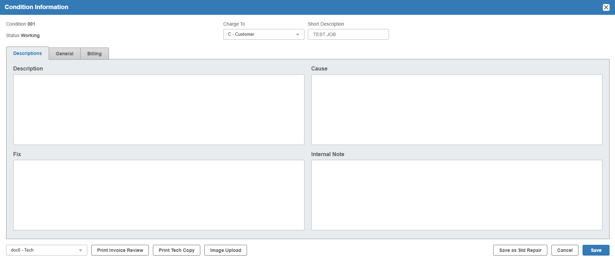

Click the Save as Std Repair button in the bottom right-hand corner of the window to save the Flat Rate Job. Another window will open:

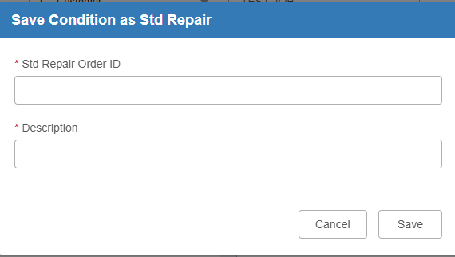

Enter a Standard Repair ID and a description for the job, then click Save. The job will now be available for use as a standard repair on future ROs/Estimates.

